### MANAGING SAFE AGILE USING AZURE DASHBOARDS – AZURE DEVOPS

#### How to use Azure Dashboards for tracking your program and manage risks before they occur and impact your delivery, the next gen DevOps.

In today’s business competition where organizations are moving gradually for federated it systems, breaking silos and **adopting agile development practices**, it really becomes **important to choose** the **right tools** for your organization in order to make this **DevOps journey smoother**.

Organizations whether large or small, are facing a real challenge in visualizing the status of overall program at an executive level today. *In order to quickly* ***check what is the current status and overturn any risks before they become*** *an impact, primarily every organization is failing and running into* ***WAR ROOMS****.* There are multiple variables to it however one of the most common question at different levels is

**“How can I see things at Bird’s View and Drill down to see what may go wrong for the upcoming release?”.**

This becomes overwhelming challenging when you start looking at a larger organization managing a complex project delivery for their customers, with multiple teams, different squads, 3-4 agile release trains and so on. It is chaotic for the executive team members who are managing large agile projects to work with cross functional and distributed teams and continue to track a program delivery and ensuring the schedules are met.

Existing tools life cycle management tools need a lot of customization effort and specialized skills to make this happen. With this it becomes difficult for a manager to have a complete visualization of the progress of his releases. He is always busy scheduling meetings and on top of continuous follow-ups (which is for sure not what you want to achieve in agile transformations).

Note: Those who are aware of SCALED AGILE FRAMEWORK – SAFE will be able to quickly realize the benefit Azure DevOps provide over other DevOps tool chain. Those who are not aware of SAFE Agile framework, I will recommend them to go through the Safe Agile Framework documentation to get an insight. However, if you are aware of agile principles and are informed about Agile Scrum then it will not be difficult to follow through the rest of the article.

Below is a quick diagram of SAFE – Essentials Figure1 (Covering SAFE is out of scope of this article.)

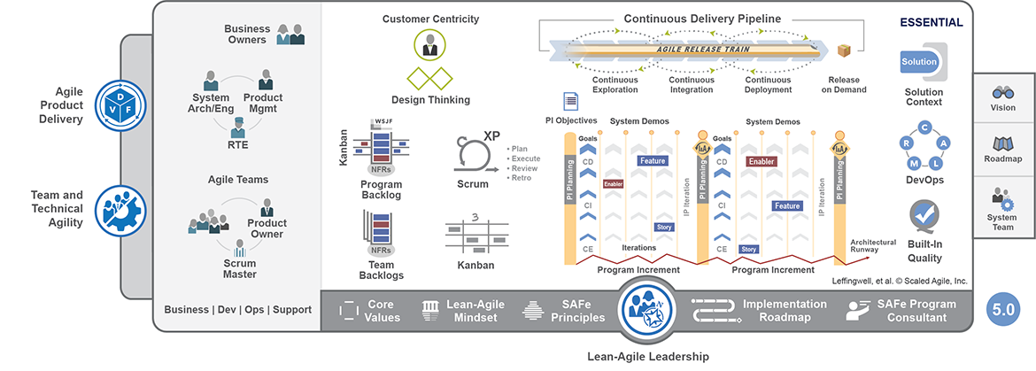

Figure 1: SAFE Essential

I will take a case example of the following three user personas who get the benefit of using Azure DevOps as a chosen platform for their Agile Transformation journey for large enterprise projects.

**Rita Meyers** is appointed as **a Program Manager** for driving one of the Key Accounts for **PullNam Inc**. where she is responsible for delivering a multi-faceted application for global mobile devices manufacturing organization who follow agile development practices to deliver their application. They have a big monolithic application suite which is further divided into 80 smaller applications but is rolled out to the customer as a single release every quarter for different customers based on the contracts.

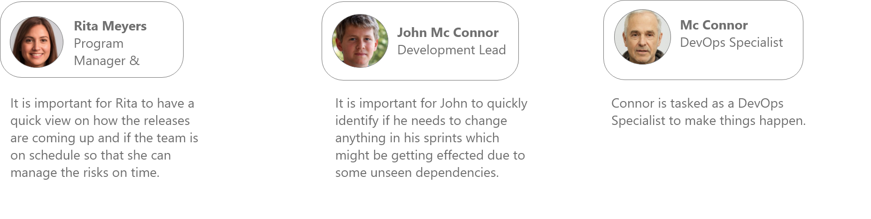

In this article I will take up a few scenarios which you must have faced in your given organization so as to collect the inputs from this article and see if it helps you in correcting some of the problem areas.

*Note: All the characters in the article are not real and fictitious, however the scenarios are picked up from real world project challenges faced off during my experience of working as a Technical Specialist and providing DevOps Solutions as an SME.*

Rita is working closely on a new product release planned to be delivered in March, which has 13 new feature updates for one of their key accounts. She calls up John (her Delivery Lead) to confirm on the status of the upcoming release. John quickly looks up on his current and future sprints dashboards and velocity reports and confirms everything looks okay as he does not see any impediments at this point of time. Rita was happy to hear that and continues on her other calls.